**Title: Analyzing the Impact Economic Development, Electricity Consumption, and Deforestation on Climate Change**

**Name : Prasad Reddy kudumula**

**Student Id : 22083068**

**Mail :** [**pk23aam@herts.ac.uk**](mailto:pk23aam@herts.ac.uk)

**Git Hub link:**

**Data Sourced :** [**Forest area -**](https://data.worldbank.org/indicator/AG.LND.FRST.ZS) [**GDP per capita -**](https://data.worldbank.org/indicator/NY.GDP.PCAP.CD) [**CO2 emissions -**](https://data.worldbank.org/indicator/EN.ATM.CO2E.PC) [**Electric power consumption -**](https://data.worldbank.org/indicator/EG.USE.ELEC.KH.PC) **[GNI per capita](https://data.worldbank.org/indicator/NY.GNP.PCAP.CD)**

**Abstract:**

This report investigates the intricate relationships among economic development, electricity consumption, deforestation, and climate change using 2014 data. Employing correlation studies and cluster analysis, the study unveils nuanced connections and sheds light on the complexities inherent in achieving sustainable development. The analysis establishes a compelling correlation between economic development, as measured by GDP per capita, and CO2 emissions. Specifically examining 2014 data, the study unveils a trend where higher GDP per capita aligns with increased CO2 emissions, underscoring the pressing need for sustainable economic practices to decouple growth from environmental harm. Examining the interplay between electricity consumption and CO2 emissions, the study reveals a direct correlation, highlighting the crucial role of electricity generation and consumption patterns in a nation's environmental footprint. The findings advocate for a transition to renewable energy sources to mitigate the impact of electric power consumption on climate change. Furthermore, the report explores the negative correlation between forest area and CO2 emissions, emphasizing the pivotal role of forests in carbon sequestration and the significance of conservation and reforestation efforts in combating climate change. The incorporation of cluster analysis adds depth to the study by categorizing countries based on multiple indicators, offering insights into distinct profiles related to economic and environmental considerations. The conclusions underscore the imperative for tailored strategies addressing the unique economic and environmental contexts of each country, promoting the simultaneous pursuit

of economic growth and environmental conservation. This study contributes valuable insights into the complex web of factors influencing climate change and lays the foundation for targeted and effective policies promoting sustainable development.

This report analyzes the relationship between economic development, electricity consumption, deforestation, and climate change using 2014 data. Through correlation studies and cluster analysis, it provides insights into how these factors interconnect, highlighting the challenges in achieving sustainable development.

1. **Impact of Economic Development on Emissions**

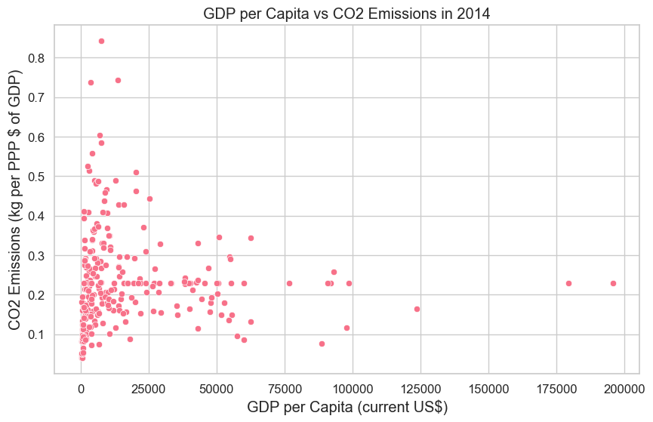

The analysis demonstrates a clear correlation between economic development, as measured by GDP per capita, and CO2 emissions. Data from the year 2014 was specifically analyzed, revealing that higher GDP per capita is often associated with increased CO2 emissions. This relationship was visualized through scatter plots, highlighting a trend where more economically developed countries tend to have higher levels of CO2 emissions. The correlation analysis suggests that economic activities, particularly those in more developed economies, are significant contributors to CO2 emissions. This finding underscores the need for sustainable economic practices that decouple economic growth from environmental degradation.

1. **Climate Change and Electric Power Consumption**

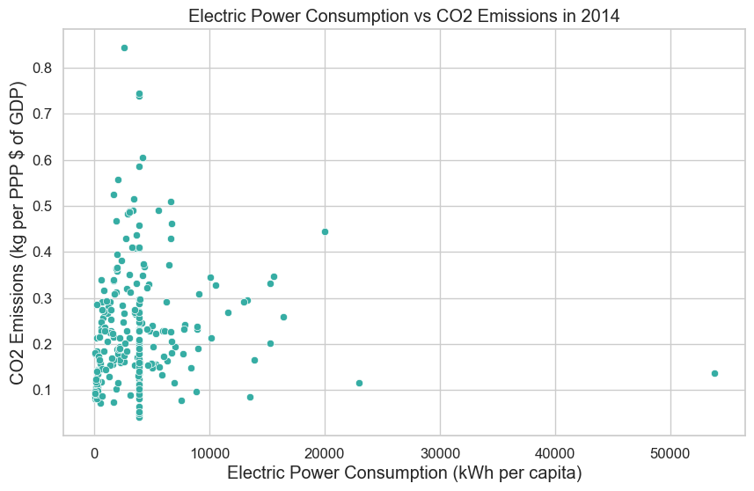

The relationship between electricity consumption and CO2 emissions was explored to understand its impact on climate change. The analysis for the year 2014 indicated a direct correlation between the two variables. Countries with higher electricity consumption showed correspondingly higher levels of CO2 emissions. This correlation suggests that the way electricity is generated and consumed has a direct bearing on the environmental footprint of a nation. The data points to the need for a shift towards renewable and cleaner sources of electricity to mitigate the impact of electric power consumption on climate change.

1. **Deforestation and Climate Change**

The analysis focused on the impact of forest area changes on CO2 emissions, a key indicator of climate change. The data from 2014 reveals a negative correlation between forest areas and CO2 emissions. Countries with larger forest areas tended to have lower CO2 emissions, suggesting that deforestation has a significant impact on climate change. This relationship was visualized using geospatial plots, illustrating the geographical distribution of forest areas in relation to CO2 emissions. The findings highlight the critical role of forests in carbon sequestration and the importance of forest conservation and reforestation efforts in combating climate change.

1. **Cluster Analysis: Grouping Countries Based on Multiple Indicators**

This cluster analysis grouped countries based on GDP per capita, forest area, electricity consumption, and CO2 emissions. The results showed distinct variations:

* **Cluster 1**: Developed countries with high GDP and CO2 emissions, varying in forest area and electricity use. These nations face high emissions due to economic growth.
* **Cluster 2**: Countries with moderate to low GDP, lower emissions, and moderate forest areas, balancing development with environmental care.
* **Cluster 3**: Developing nations with low GDP and emissions, but larger forest areas. They have lower emissions but are more vulnerable to climate change.
* **Cluster 4**: Less industrialized countries with extremely low GDP and minimal emissions, showing minimal environmental impact but lower economic development.

This analysis provides insights into how different countries' economic and environmental profiles impact and are impacted by climate change. It underscores the importance of customized strategies for climate change mitigation and sustainable development, tailored to each country's unique situation.

1. **Conclusion**

the analysis reveals significant links between GDP, electricity usage, deforestation, and CO2 emissions, emphasizing the need for sustainable development strategies. The findings stress the importance of tailored approaches for different countries to balance economic growth with environmental conservation.